Minor Arc
# Source: AI Source: Provided by: [Data Path: Persons Table -> ID Column: 1, Name_En Column: Motasem Essam] -> From: [ChatGPT] on [7/25/2026]
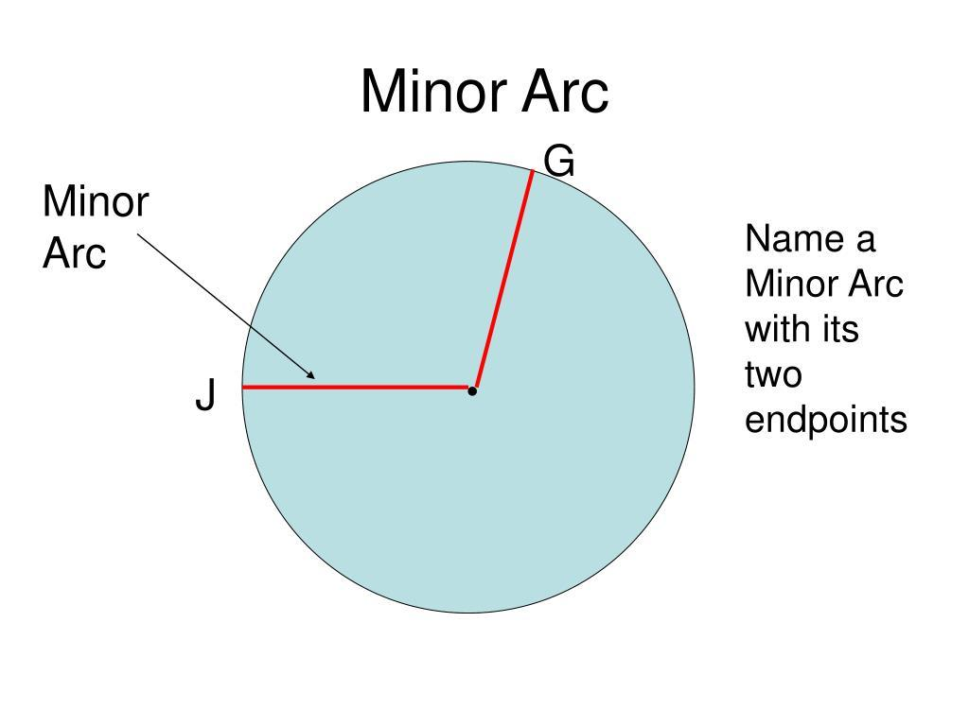
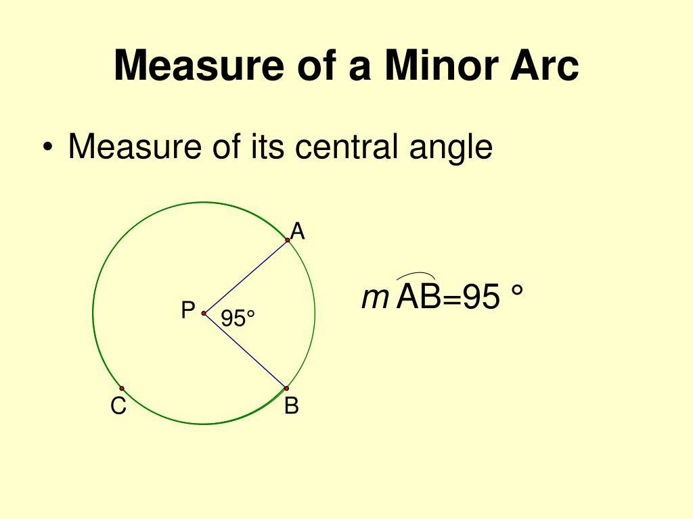
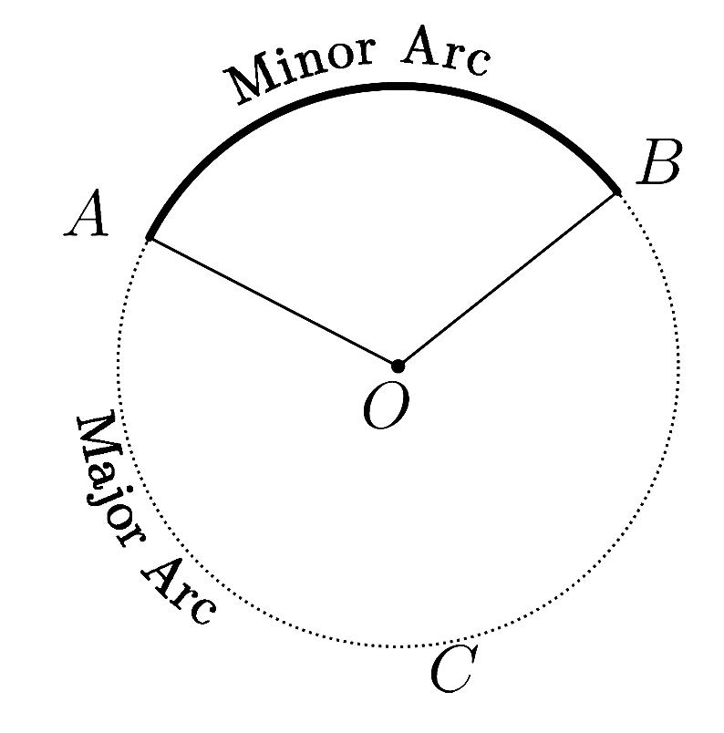
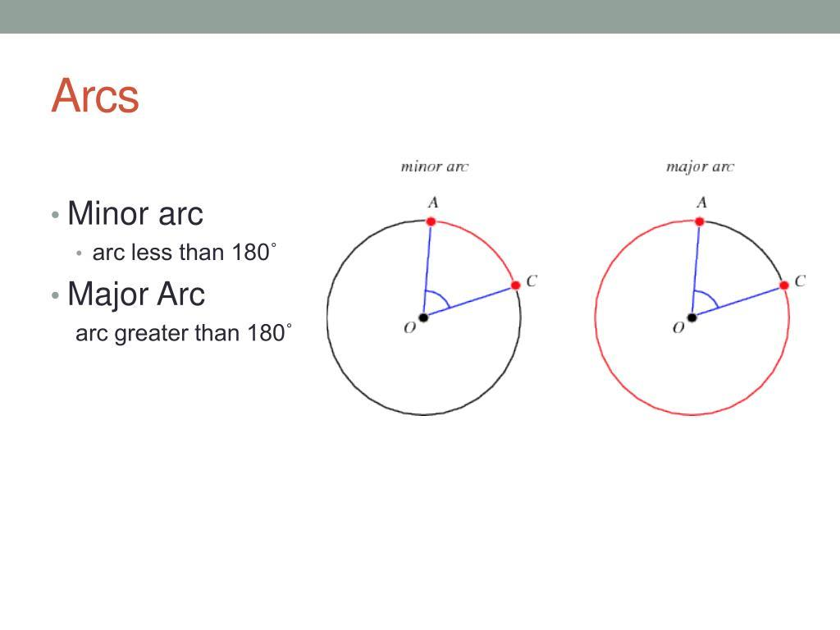
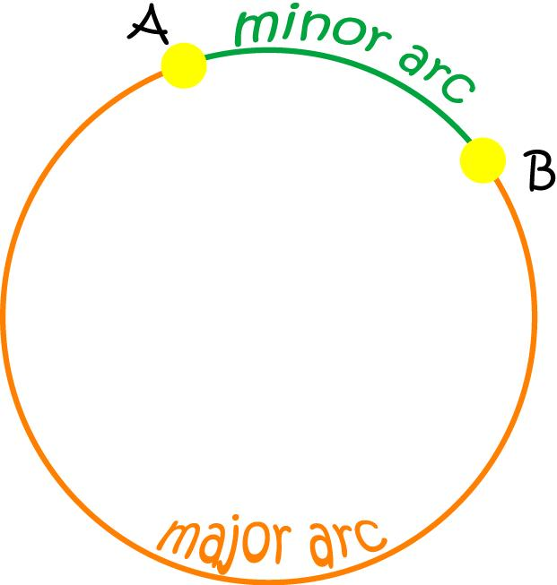

Definition
# Source: AI Source: Provided by: [Data Path: Persons Table -> ID Column: 1, Name_En Column: Motasem Essam] -> From: [ChatGPT] on [7/25/2026]
A Minor Arc is an arc of a circle that measures less than 180°.
It is the shorter arc between two points on a circle, except when the two points are endpoints of a diameter, in which case each arc is a semicircle.
If $A$and $B$are points on a circle, the minor arc from $A$to $B$is commonly written as:
$$\hat{AB}$$
provided the intended arc is the shorter one.

Fundamental Concept
# Source: AI Source: Provided by: [Data Path: Persons Table -> ID Column: 1, Name_En Column: Motasem Essam] -> From: [ChatGPT] on [7/25/2026]
A minor arc is determined by:
- Two endpoints on the circle
- The curved portion of the circumference connecting those endpoints
- A corresponding central angle measuring less than ${180}^{∘}$
For a minor arc $\hat{AB}$:
$$m\left(\hat{AB}\right)=m\left(∠AOB\right)$$
where $O$is the center of the circle.
Therefore:
$$0^{∘}<m\left(\hat{AB}\right)<{180}^{∘}$$

Main Parts
# Source: AI Source: Provided by: [Data Path: Persons Table -> ID Column: 1, Name_En Column: Motasem Essam] -> From: [ChatGPT] on [7/25/2026]
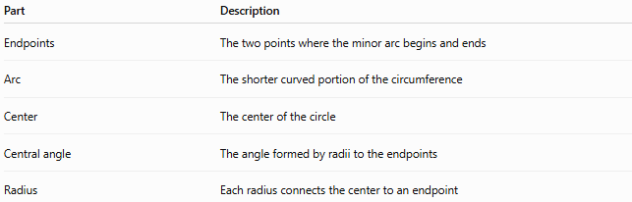
Part | Description
Endpoints | The two points where the minor arc begins and ends
Arc | The shorter curved portion of the circumference
Center | The center of the circle
Central angle | The angle formed by radii to the endpoints
Radius | Each radius connects the center to an endpoint

Classification
# Source: AI Source: Provided by: [Data Path: Persons Table -> ID Column: 1, Name_En Column: Motasem Essam] -> From: [ChatGPT] on [7/25/2026]
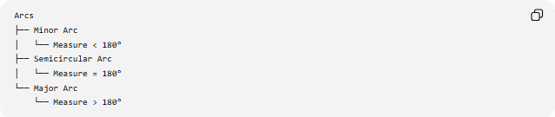
Arcs
├── Minor Arc
│ └── Measure < 180°
├── Semicircular Arc
│ └── Measure = 180°
└── Major Arc
└── Measure > 180°

Mathematical Representation
# Source: AI Source: Provided by: [Data Path: Persons Table -> ID Column: 1, Name_En Column: Motasem Essam] -> From: [ChatGPT] on [7/25/2026]
For a circle with radius $r$and minor-arc central angle $θ$:
Arc Measure
$$0^{∘}<θ<{180}^{∘}$$
Arc Length
When $θ$is measured in degrees:
$$L=\frac{θ}{{360}^{∘}}\left(2πr\right)$$
When $θ$is measured in radians:
$$L=rθ$$
Example
Suppose a circle has radius $6\text{ cm}$, and the central angle is ${80}^{∘}$.
Because:
$${80}^{∘}<{180}^{∘}$$
the corresponding arc is a minor arc.
Its length is:
$$L=\frac{{80}^{∘}}{{360}^{∘}}\left(2π⋅6\right) \\ L=\frac{8π}{3}\text{ cm} \\ L≈8.38\text{ cm}$$

Important Properties
# Source: AI Source: Provided by: [Data Path: Persons Table -> ID Column: 1, Name_En Column: Motasem Essam] -> From: [ChatGPT] on [7/25/2026]
- A minor arc has a measure less than ${180}^{∘}$.
- It is the shorter arc between two non-diameter endpoints.
- Its corresponding central angle is less than ${180}^{∘}$.
- Its arc length is less than half the circumference.
- Two endpoints of a minor arc determine a corresponding major arc using the same endpoints.
- A minor arc and its corresponding major arc together make the full circumference.
Thus:
$$m\left(\text{Minor Arc}\right)+m\left(\text{Major Arc}\right)={360}^{∘}$$

Minor Arc and Chord
# Source: AI Source: Provided by: [Data Path: Persons Table -> ID Column: 1, Name_En Column: Motasem Essam] -> From: [ChatGPT] on [7/25/2026]
A minor arc is curved, while its corresponding chord is straight.
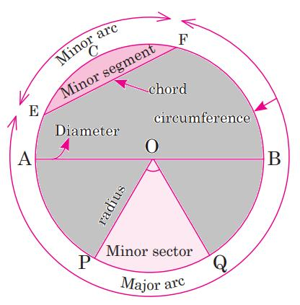
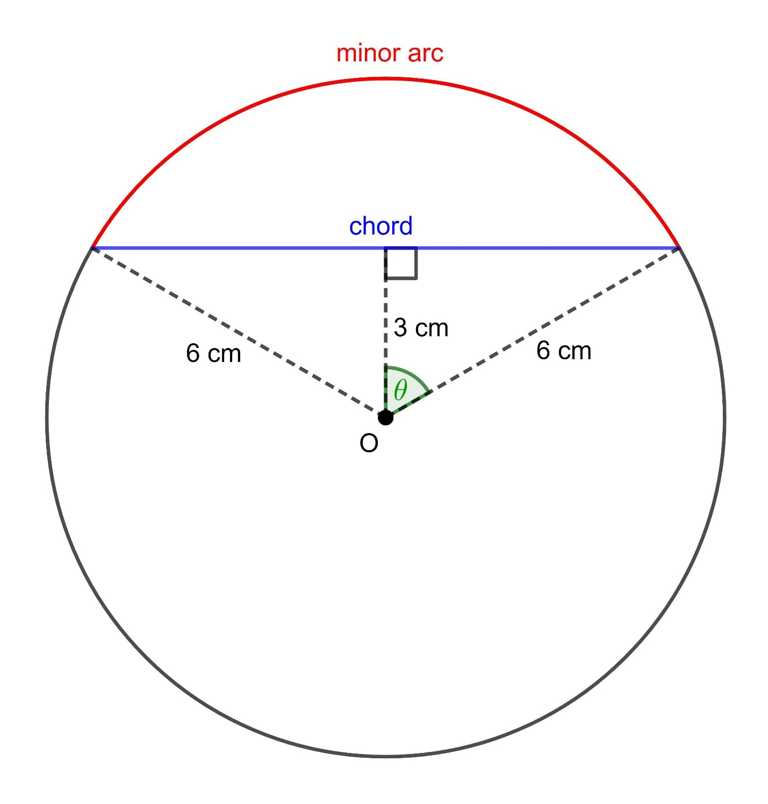
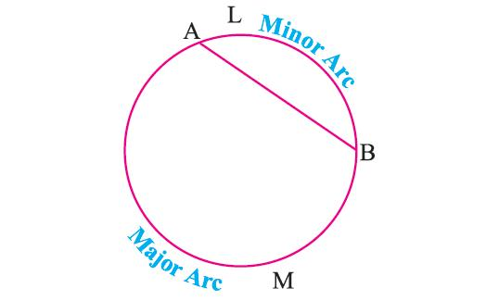
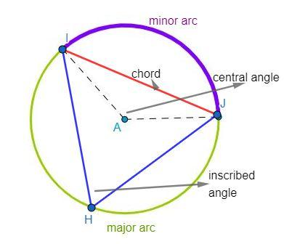
For endpoints $A$and $B$:
- $\hat{AB}$→ minor arc
- $\overset{‾}{AB}$→ chord
The chord is the straight-line segment connecting the endpoints of the arc.

Minor Arc and Central Angle
# Source: AI Source: Provided by: [Data Path: Persons Table -> ID Column: 1, Name_En Column: Motasem Essam] -> From: [ChatGPT] on [7/25/2026]
The measure of a minor arc equals the measure of its central angle:
$$m\left(\hat{AB}\right)=m\left(∠AOB\right)$$
For example, if:
$$m\left(∠AOB\right)={120}^{∘}$$
then:
$$m\left(\hat{AB}\right)={120}^{∘}$$
and the arc is a minor arc because ${120}^{∘}<{180}^{∘}$.

Minor Arc and Inscribed Angle
# Source: AI Source: Provided by: [Data Path: Persons Table -> ID Column: 1, Name_En Column: Motasem Essam] -> From: [ChatGPT] on [7/25/2026]
An inscribed angle intercepting a minor arc has a measure equal to half the measure of that arc:
$$m\left(∠ACB\right)=\frac{1}{2}m\left(\hat{AB}\right)$$
For example, if:
$$m\left(\hat{AB}\right)={100}^{∘}$$
then:
$$m\left(∠ACB\right)={50}^{∘}$$

Minor Arc vs. Major Arc
# Source: AI Source: Provided by: [Data Path: Persons Table -> ID Column: 1, Name_En Column: Motasem Essam] -> From: [ChatGPT] on [7/25/2026]
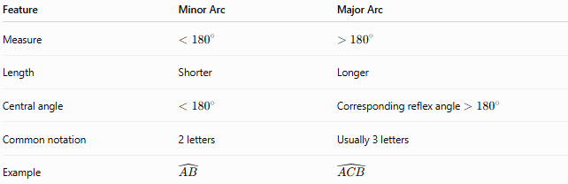
Feature | Minor Arc | Major Arc
Measure | $$<{180}^{∘}$$ | $$>{180}^{∘}$$
Length | Shorter | Longer
Central angle | $$<{180}^{∘}$$ | Corresponding reflex angle $>{180}^{∘}$
Common notation | 2 letters | Usually 3 letters
Example | $$\hat{AB}$$ | $$\hat{ACB}$$

Naming a Minor Arc
# Source: AI Source: Provided by: [Data Path: Persons Table -> ID Column: 1, Name_En Column: Motasem Essam] -> From: [ChatGPT] on [7/25/2026]
A minor arc is normally named using two letters, representing its endpoints:
$$\hat{AB}$$
The two-letter notation conventionally identifies the minor arc when there is no ambiguity.
A three-letter notation can also be used when it is necessary to specify which route between the endpoints is intended.

Special Case
# Source: AI Source: Provided by: [Data Path: Persons Table -> ID Column: 1, Name_En Column: Motasem Essam] -> From: [ChatGPT] on [7/25/2026]
If the endpoints of an arc are the endpoints of a diameter, the two possible arcs each measure:
$${180}^{∘}$$
These are semicircular arcs, not minor arcs.
Therefore:
- $<{180}^{∘}$→ Minor Arc
- $={180}^{∘}$→ Semicircular Arc
- $>{180}^{∘}$→ Major Arc

Relationship to the Circle
# Source: AI Source: Provided by: [Data Path: Persons Table -> ID Column: 1, Name_En Column: Motasem Essam] -> From: [ChatGPT] on [7/25/2026]
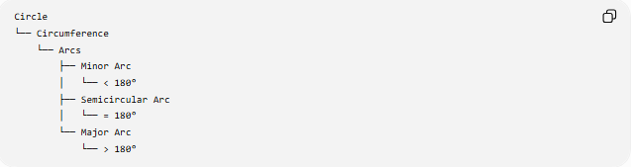
Circle
└── Circumference
└── Arcs
├── Minor Arc
│ └── < 180°
├── Semicircular Arc
│ └── = 180°
└── Major Arc
└── > 180°

Key Points
# Source: AI Source: Provided by: [Data Path: Persons Table -> ID Column: 1, Name_En Column: Motasem Essam] -> From: [ChatGPT] on [7/25/2026]
- A Minor Arc is the shorter arc between two points on a circle.
- Its measure is less than ${180}^{∘}$.
- Its corresponding central angle also measures less than ${180}^{∘}$.
- Its arc length can be calculated using the fraction of the circumference represented by the central angle.
- The same two endpoints also determine a major arc.
- When the endpoints form a diameter, the arcs are semicircular arcs, not minor arcs.

Conclusion
# Source: AI Source: Provided by: [Data Path: Persons Table -> ID Column: 1, Name_En Column: Motasem Essam] -> From: [ChatGPT] on [7/25/2026]
A Minor Arc is the portion of a circle's circumference measuring less than ${180}^{∘}$. It represents the shorter curved path between two points on a circle and corresponds directly to a central angle of the same measure. It is one of the three fundamental arc classifications: minor arc, semicircular arc, and major arc.

